OIL CONDITION MONITORING REPORT SLNS SAYURA

ENGINE PARTICULARS (Information provided by the customer)
 | Port Main Engine (No. 02)
Make : | SEMT PIELSTICK
Model : | 16 PA 6V 280
Sr.No’s: | 8292
Sampling Date | 07 May 25
Sampling point : | Lube oil sump
Sampling Method : | Extraction
Type of Lubricant : | Shell Gadinia S3 40
System Capacity : | 1400 Ltrs

RUNNING HRS DETAILS (Information provided by the customer)
 | Port Main Engine (No. 02)
Sample ID | M010168
Oil Running Hours | 1232.55
Total Running Hours of the Machinery | 49879.50

ANALYSIS RESULTS
Basic Properties
 | ASTM Method | Fresh Oil  (As per OEM data sheet) | Uncertainty  (K=2) | Port Main Engine  (S/I- M010168)
Viscosity @ 40ºC (cSt) | ASTM D 445 | 128.00 | 0.006 | 120.44
Viscosity @ 100ºC (cSt) | ASTM D 445 | 13.70 | 0.005 | 13.55
Viscosity Index | ASTM D2270 | 103 | N/A | 108.84
Total Base No. mg KOH/g | ASTM D 4739 | 10.48* | 0.77 | 8.81
Flash Point (cº) | ASTM D 92 | 230 | 0.026 | 208
Water content % | ASTM D 95 | < 0.2 | 0.082 | <0.1

*The results were taken from a fresh oil sample which is tested at MTTU laboratory by ASTM D4739 method.

Elemental Concentration as per ASTMD 5185 (ppm)
Element | Maximum Permissible Limit | Fresh Oil Sample | Uncertainty  (K=2) | Port Main Engine  (S/I- M010168)
Fe | 80 | < 1.000 | 0.15 | 9.262
Cr | 10 | < 1.000 | 0.18 | < 1.000
Si | 15 | < 1.000 | 0.17 | < 1.000
Al | 20 | < 1.000 | 0.28 | 1.110
Pb | 20 | < 1.000 | 0.13 | < 1.000
Cu | 25 | < 1.000 | 0.17 | 1.912
Sn | 10 | < 1.000 | 0.20 | < 1.000
Ni | 10 | < 1.000 | 0.08 | < 1.000

TREND ANALYSIS WITH PREVIOUS REPORTS

 |  |  | Fresh Oil Sample | Port Main Engine
 |  |  | Fresh Oil Sample | S/I-M000083 |  | S/I-M000327 | S/I-M000780 | S/I-M001120 | S/I-M002381 | Fresh Oil Sample | S/I-M003965 | S/I-M004958 | S/I-M005411 | S/I-M005944 | S/I-M006303 | S/I-M007875 | S/I-M008480 | S/I-M009276 | S/I-M010168
Oil Running Hrs |  |  | - | 70.55 |  | 98.15 | 634.25 | 1035.25 | 686.40 | - | 464.10 | 1313.15 | 1492.30 | 70.45 | 317.30 | 567.30 | 732.55 | 982.55 | 1232.55
T/R/H of Machinery |  |  | - | 45637.45 |  | 45662.20 | 46201.15 | 46602.15 | 47753.30 | - | 48217.40 | 48467.40 | 48646.55 | 48717.40 | 48964.25 | 49214.25 | 49379.50 | 49629.50 | 49879.50
Basic Properties
Viscosity @ 40ºC (cSt) |  |  | 139.00 |  | N/A | 128.17 | 118.68 | 133.09 | 134.23 | 128.00 | 122.91 | 119.37 | 120.06 | 124.85 | 124.22 | 112.52 | 114.01 | 115.55 | 120.44
Viscosity @ 100ºC (cSt) |  |  | 14.40 |  | N/A | 13.28 | 13.34 | 13.90 | 14.36 | 13.70 | 13.22 | 12.88 | 12.59 | 13.12 | 13.55 | 12.90 | 13.05 | 13.06 | 13.55
Viscosity Index |  |  | 103 |  | N/A | N/A | 107.80 | 100.83 | 105.57 | 103 | 101.59 | 100.51 | 95.94 | 98.47 | 104.82 | 108.48 | 108.94 | 107.34 | 108.84
Total Base No. (mg KOH/g) |  |  | 10.48* |  | N/A | N/A | N/A | N/A | N/A | 10.48* | 8.47 | 8.78 | 8.31 | 8.74 | N/A | N/A | 8.30 | 8.40 | 8.81
Water content (%) |  |  | <0.2 |  | N/A | N/A | N/A | N/A | N/A | <0.2 | <0.1 | <0.1 | <0.1 | <0.1 | N/A | N/A | 206 | 204 | 208
Flash Point (ºC) |  |  | 225 |  | N/A | N/A | N/A | N/A | N/A | 230 | 195 | 195 | 170 | 190 | N/A | N/A | <0.1 | <0.1 | <0.1
Elemental Concentration as per ASTMD 5185 (ppm)
Element | Max. Permissible Limit
Fe | 80 | < 1.000 |  | 2.133 |  | 3.239 | 4.951 | 6.087 | 8.240 | < 1.000 | 13.054 | 16.115 | 10.01 | 3.375 | 4.390 | 6.209 | 6.848 | 9.262 | 9.040
Cr | 10 | < 1.000 |  | < 1.000 |  | < 1.000 | < 1.000 | < 1.000 | < 1.000 | < 1.000 | < 1.000 | 1.018 | < 1.000 | < 1.000 | < 1.000 | < 1.000 | < 1.000 | < 1.000 | < 1.000
Si | 15 | < 1.000 |  | 5.737 |  | 10.346 | 6.931 | 2.490 | 3.979 | < 1.000 | 6.157 | 6.845 | 6.621 | 6.981 | 6.439 | 8.481 | 3.577 | < 1.000 | < 1.000
Al | 20 | < 1.000 |  | 3.389 |  | 1.672 | 1.852 | 1.992 | < 1.000 | < 1.000 | 1.337 | 1.795 | < 1.000 | < 1.000 | 1.136 | < 1.000 | 1.132 | 1.110 | < 1.000
Pb | 20 | < 1.000 |  | < 1.000 |  | 6.331 | < 1.000 | 4.007 | < 1.000 | < 1.000 | 1.579 | < 1.000 | < 1.000 | 3.242 | < 1.000 | < 1.000 | < 1.000 | < 1.000 | 1.091
Cu | 25 | < 1.000 |  | 1.129 |  | 1.769 | 3.470 | 1.331 | 1.302 | < 1.000 | 3.301 | 4.624 | 3.029 | 3.294 | < 1.000 | 2.310 | 2.084 | 1.912 | 4.625
Sn | 10 | < 1.000 |  | 1.867 |  | <1.000 | <1.000 | < 1.000 | < 1.000 | < 1.000 | < 1.000 | < 1.000 | < 1.000 | < 1.000 | < 1.000 | < 1.000 | < 1.000 | < 1.000 | < 1.000
Ni | 10 | < 1.000 |  | <1.000 |  | <1.000 | <1.000 | < 1.000 | < 1.000 | < 1.000 | < 1.000 | < 1.000 | N/A | N/A | N/A | < 1.000 | < 1.000 | < 1.000 | < 1.000
N/C-Not Conducted

Wear Metals
Port Main Engine
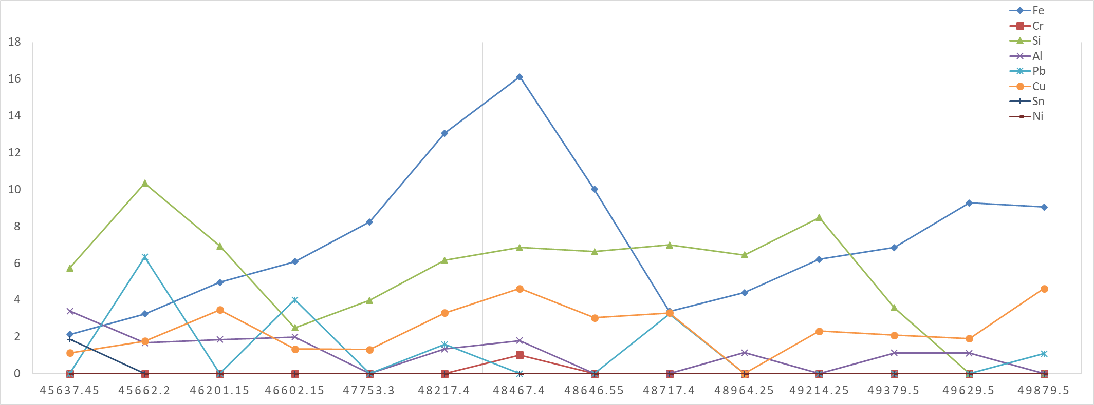

ppm

Total Running Hrs

Viscosity
40⁰C 100⁰C
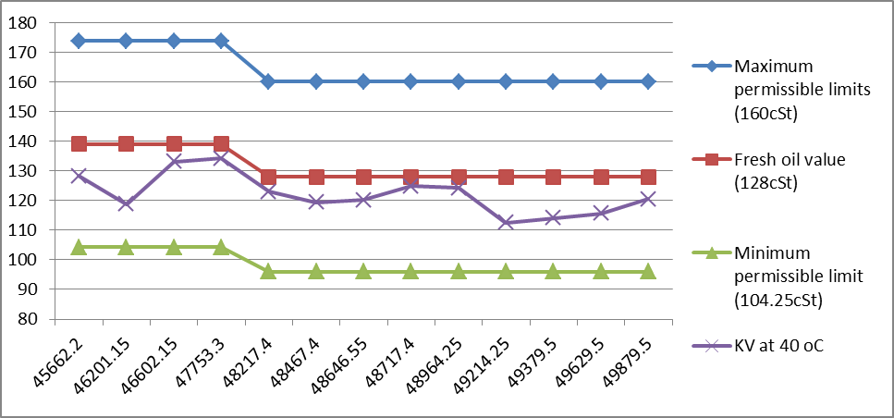
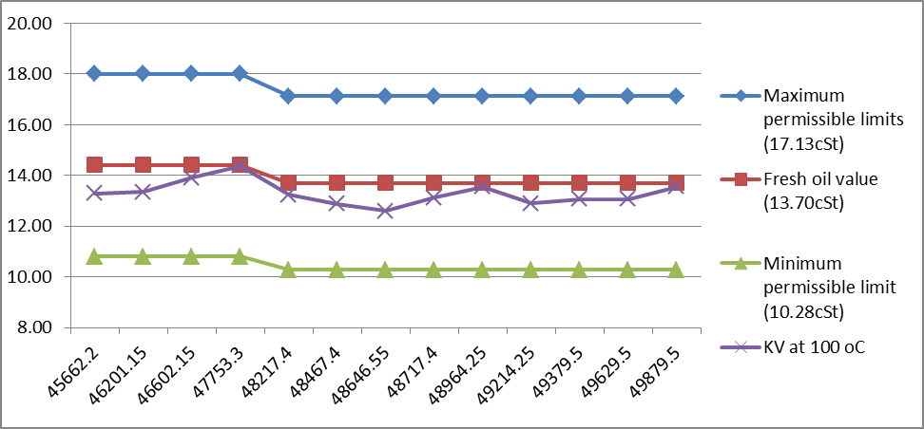

(cSt)
(cSt)
Total Running Hrs

Total Running Hrs

Total Running Hrs
Total Running Hrs

ME (PdM) I/II

